| **Test Name** | Automated Operations: Pump continues to run while tank is filling |
| --- | --- |
| **Use Case Tested:** | Automated Operations |
| **Test Description:** | Verifies that the business rules do not send pump on or off messages while the tank between low and high-level thresholds. |
| **Pre-conditions** | * Pump is running. * Dashboard state of pump: running. * ThingsBoard has not asked the pump to stop via manual operation. * The “switch pump of when tank level is above” field is set to 2 metres. |
| **Post-conditions** | No change to System. Business rules have not sent a message to start the pump as the pump is already running. |
| **Notes:** | **This test can be run immediately after BPST002, the pre-conditions will be met.**  **This is a negative test – there will be no visible change in UI or pump controller state.** |

|  | **TEST STEP** | **EXPECTED TEST RESULTS** |
| --- | --- | --- |
|  | Use Simulator to send tank sensor message with a level of 1.99 metres. | No change to UI other than the tank level indicator. |
|  | Command the pump controller to send a status message. | No change to UI |

|  |  |  |  |  |  |
| --- | --- | --- | --- | --- | --- |
| **Test Data Table** | | | | | |
|  | **1** | **2** | **3** | **4** | **5** |
| [Data field 1] | [data set 1 input value for field 1] |  |  |  |  |
| [Data field 2] | [data set 1 input value for field 2] |  |  |  |  |
| [Data field 3] | [data set 1 input value for field 3] |  |  |  |  |

**Results**

26/08/2020

Passed.

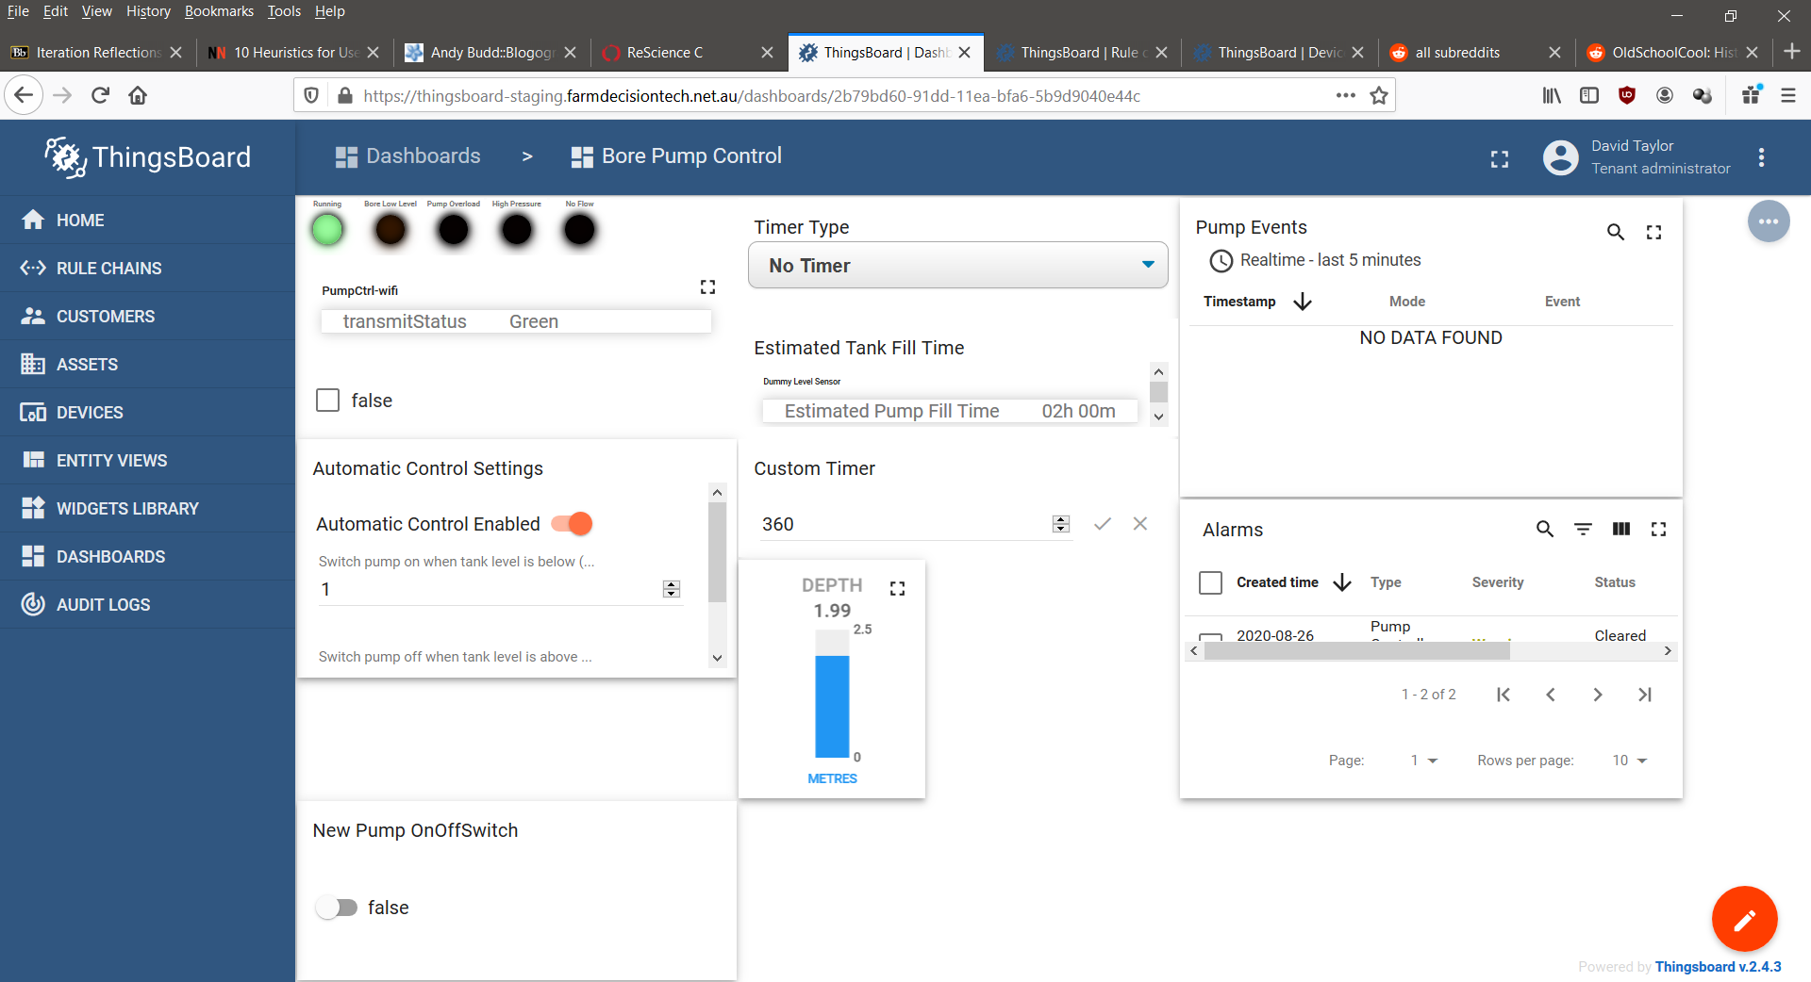

02/09/2020

Passed.

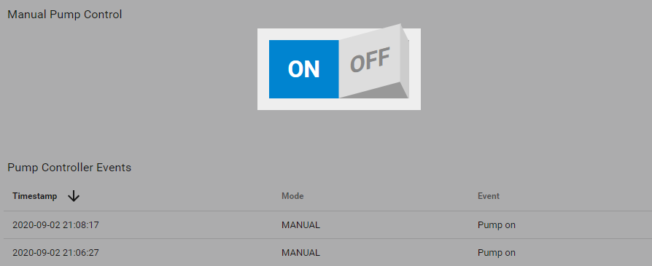

9/9/2020 – On site test at OAI.

Success.

10:28:12.630 -> Send operator requested status message.

10:28:12.630 -> LoRaWAN will encode and send this message: {'pumpRunning':1,'boreLowLevel':0,'softStartFail':0,'pumpOverload':0,'controllerRestart':0,'highPressure':0,'noFlow':0}

10:28:12.630 -> Sending status byte: 01

10:28:14.752 -> EV_TXCOMPLETE (includes waiting for RX windows)

